DC circuits with NPN BJTs and resistors
Determine the voltage at the labeled nodes. Determine collector, base and emitter currents.
- If the BJT is in the active region, assume V_{be} = 0.7V, ß = 100, and i_{c}=i_{e}.
- If the BJT is in saturation, assume that V_{ce} = 0.2V.
- Only compute ß when the BJT is in saturation.
- Write your answers on the table shown on the page following the problems.
- On separate page(s), show your work for each problem. Denote the operating region of BJTs by writing ACT/SAT next to active/saturated mode BJTs respectively.
- Write “unknown” for circuits whose current/voltage cannot be determined.
- Round you answer to 2-significant figures and include units.
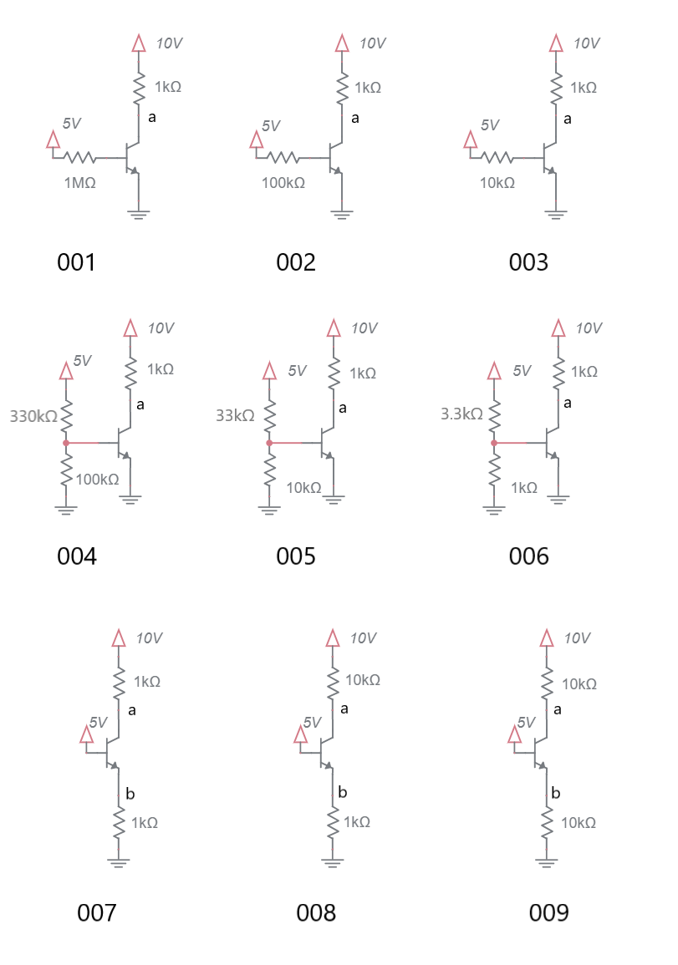
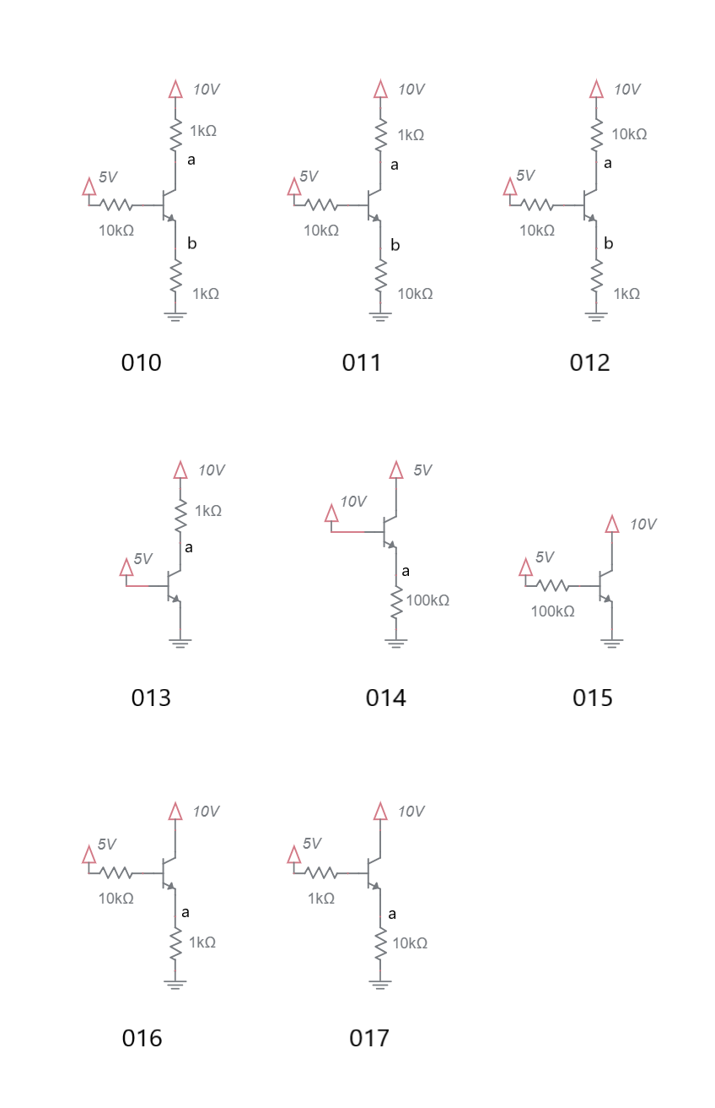

Problem |  | a | b | ic | ib | ie | ß
001
002
003
004
005
006
007
008
009
010
011
012
013
014
015
016
017

DC circuits with PNP BJTs and resistors
Determine the voltage at the labeled nodes. Determine collector, base and emitter currents.
- If the BJT is in the active region, assume V_{eb} = 0.7V, ß = 100, and i_{c}=i_{e}.
- If the BJT is in saturation, assume that V_{ec} = 0.2V.
- Only compute ß when the BJT is in saturation.
- Write your answers on the table shown on the page following the problems.
- On separate page(s), show your work for each problem. Denote the operating region of BJTs by writing ACT/SAT next to active/saturated mode BJTs respectively.
- Write “unknown” for circuits whose current/voltage cannot be determined.
- Round you answer to 2-significant figures and include units.
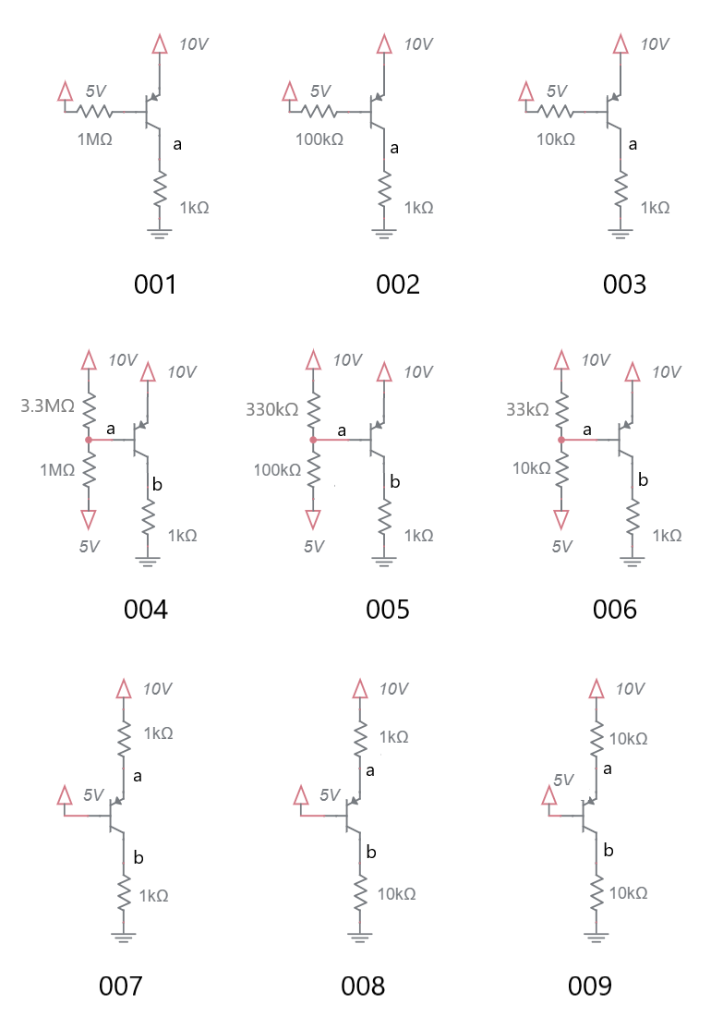
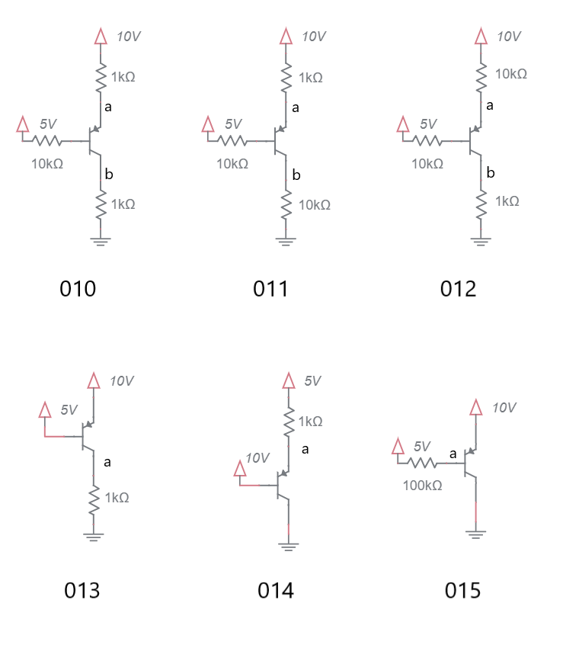

Problem |  | a | b | ic | ib | ie | ß
001
002
003
004
005
006
007
008
009
010
011
012
013
014
015

BJT Current Sources and mirrors
If the BJT is in the active region, assume V_{be} = 0.7V, ß = 100, i_{c}=i_{e}.
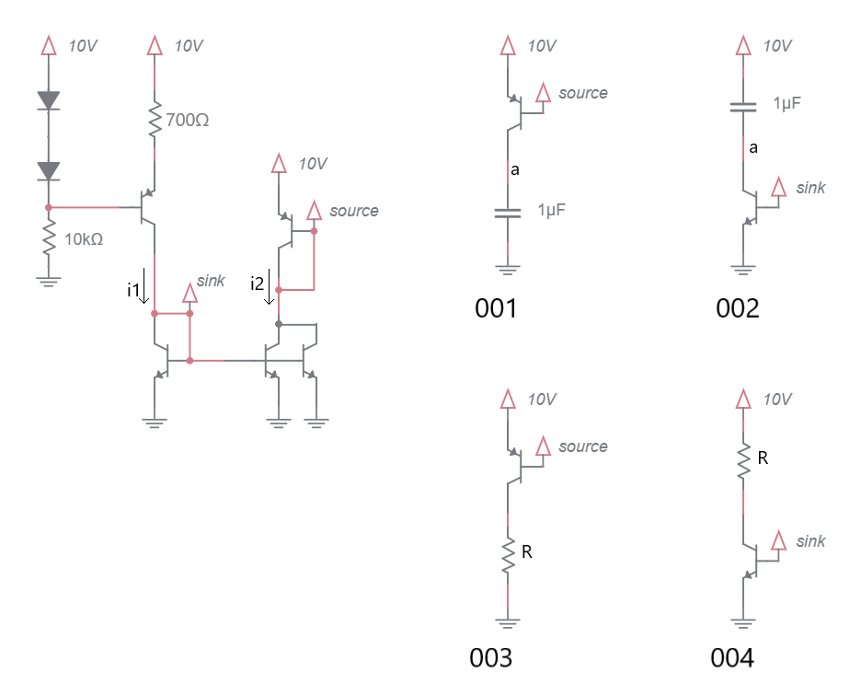
- Determine the currents i1 and i2.

- What is the range (upper and lower) of resistance in the circuits 003 and 004 to keep their BJTs in the active region?

- Plot the volage at point a in circuits 001 and 002 assuming the capacitor is discharge at time 0. Use the following questions to guide yourself to the answer.
  - Using the voltage/current equation for a capacitor, find dv/dt for 001 and 002.

  - Since the initial voltage drop across the capacitors is 0V, what is the initial value of a?

  - Since the final voltage drop across the capacitors is 10V, what is the final value of a?

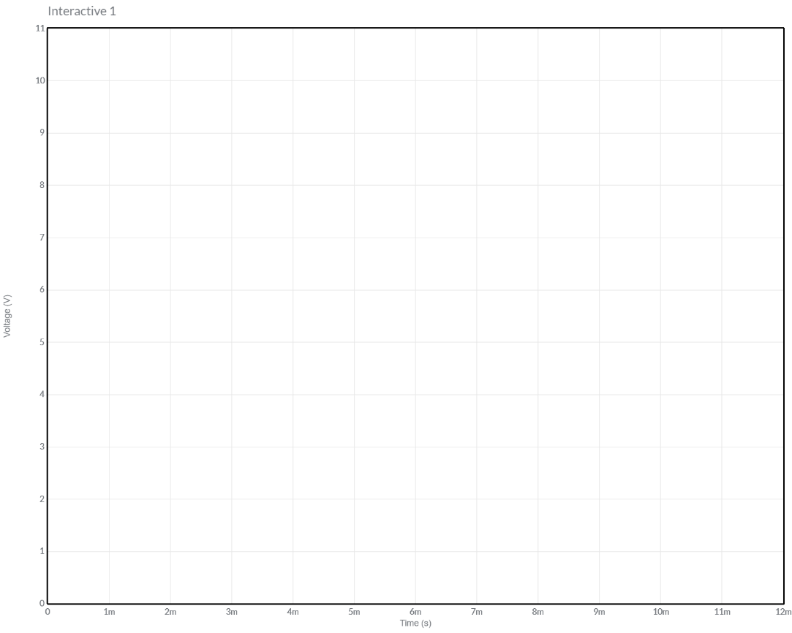
Figure 2: Plot the voltage at node a for the circuits shown in 001 and 002

Practical Application – Power dissipated by BJT
You are required to illuminate a Cree Xlamp XM-L2 High Power LED using a current source. The LED has a I vs. V curve is shown at left in Figure 1. Your current source, shown at right in Figure 1, uses a TIP31 (a high powered NPN transistor) and a 2.7V Zener diode. You need to run the LED at 2 amps.
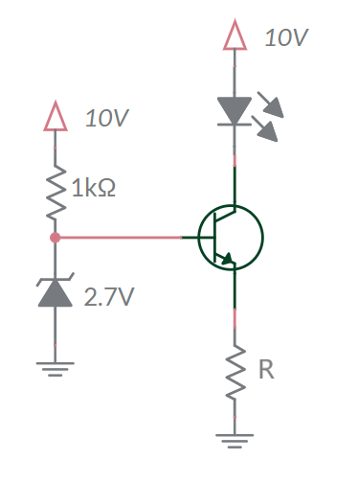
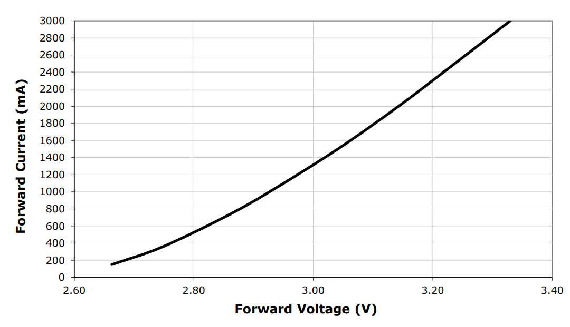
Figure 3: (Left) I/V curve for a Cree Xlamp XM-L2 High Power LED. (Right) The constant current source used to drive the LED.
- What is the emitter voltage?

- What value of emitter resistor, R, will produce the needed 2A through the LED?

- What is the voltage drop across the LED at 2A?

- What is the power dissipated by the LED at 2A?

- What is the power dissipated by the resistor R at 2A?

- What is the voltage across the BJT at 2A?

- What is the power dissipated by the BJT at 2A?

- How can you reduce the power dissipation of the BJT while keeping 2A running through the LED? Do not change the circuit topology.

Practical Application - Cross Over Distortion
The blue sine wave shown in the graph below is applied as the input, V_{in}, to the circuit shown below at right. Determine the output, V_{out}, and graph it on the graph below. The value of the load resistor, R_{L} is unimportant.
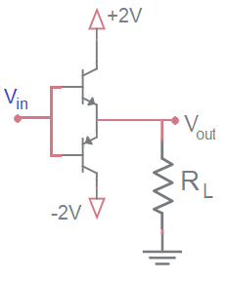
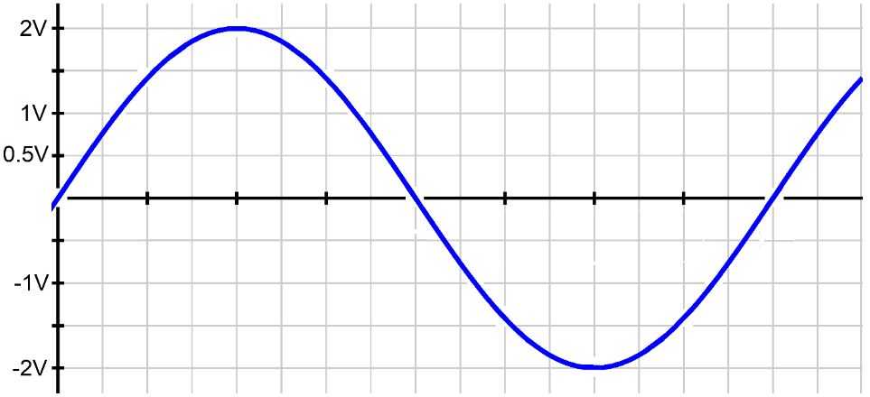

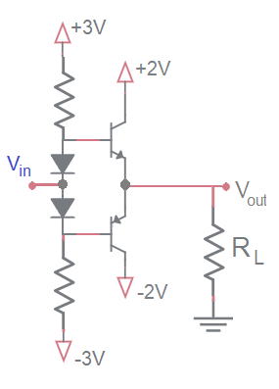
The blue sine wave shown in the graph below is applied as the input, V_{in}, to the circuit shown below at right. Determine the output, V_{out}, and graph it on the graph below. The value of the resistors are unimportant.


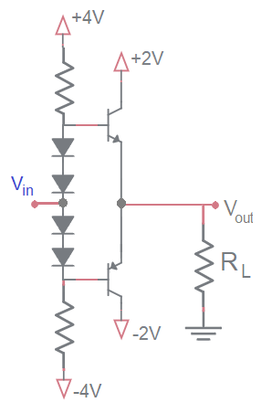
The blue sine wave shown in the graph below is applied as the input, V_{in}, to the circuit shown below at right. Determine the output, V_{out}, and graph it on the graph below. The value of the resistors are unimportant.


Practical Application – Negative feedback by emitter degeneration
In the Ebers-Moll equation of a BJTs the collector current is described as
$$I_{C}=I_{S}e^{\frac{V_{BE}}{V_{T}}}$$
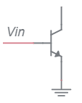
The I_{S} term, the reverse saturation current, is strongly temperature dependent. According to multiple sources, it doubles for every 10°C rise in temperature. This dependency can lead to thermal runaway in the common emitter circuit show at right. In the following questions assume that Vin is constant and that the BJT is operating in the active region.
- Look at the schematic at right, does the base emitter voltage depend on the collector current?

- If the temperature of the BJT increases, does I_{s} increase or decrease?

- If I_{S} increases, does I_{C} increase or decrease?

- If I_{C} increases does the power dissipated by the BJT increase or decrease? Assume V_{C} is constant.

- If the power dissipated by the BJT increases, does the temperature of the BJT increase or decrease?

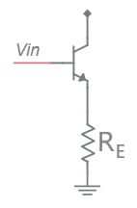
From these inferences you should see that an increase in the BJT’s temperature causes further increase in the temperature of the BJT – thermal runaway. This is an example of positive feedback – a tendency of a system to increase a parameter without bound. While you may like positive feedback, electrical systems can do bad things when they have too much positive feedback.
Now consider the circuit shown at right. This is a common emitter with emitter degeneration resistor. As we will see, the addition of a resistor to the emitter adds negative feedback which greatly decreases the tendency of the BJT to experience thermal runaway. In the following questions assume that Vin is constant and that the BJT is operating in the active region.
- Look at the schematic at right. Does the base emitter voltage increase or decrease when the emitter current increases?

- When the collector current increases, does the emitter current increase or decrease?

- If the temperature of the BJT increases, does I_{s} increase or decrease?
- If I_{S} increases, does I_{C} increase or decrease?

- If I_{C} increases, does I_{E} increase or decrease?

- If I_{E} increases, does V_{E} increase or decrease?

- If V_{E} increases, does V_{BE} increase or decrease? Assume that V_{B} is being held constant.

- If V_{BE} decreases, does I_{C} increase or decrease?

- If I_{C} decreases, does the power dissipated by the BJT increase or decrease?

- If the power dissipated by the BJT decreases, does the temperature of the BJT increase or decrease?

The ability of the deceasing V_{BE} being able to keep the increasing I_{S} in check depends on the magnitude of the emitter resistor. If it the emitter resistor is too small, then the BJT may still exhibit thermal runaway. In that case, you should increase the emitter resistor until thermal runaway is kept in check.
Now, let’s see if you can make a feedback diagram to describe this negative feedback using the diagram below. Annotate the diagram according to the instructions below.
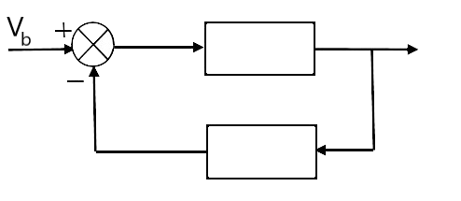
- Make the reference input equal to V_{b} (this is the input at the left).
- What must the inverting input to the summer junction be for the output of the summer junction to be V_{be}? Write this signal and V_{be} on the diagram.
- Fill in the upper block with the right-hand side of the Ebers-Moll equation.
- Label the output of the block diagram with the left-hand side of the Ebers-Moll equation. This should make sense because the Ebers-Moll equation is a bunch of constants with two variables.
- Fill in the lower block with an equation which converts the block diagram output into the variable used in the inverting input to the summer junction. Hint, its Ohm’s law.

